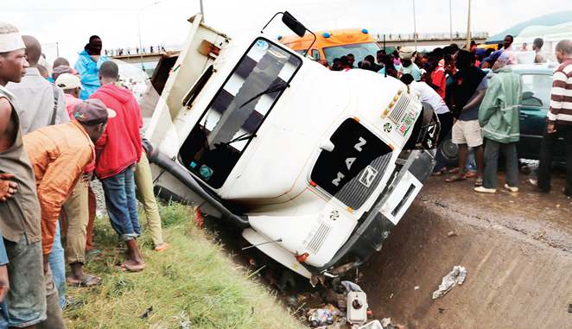
An idea of what happened in the Benin – Asaba – Onitsha Expressway accident. Source: Financial Watch

